**GUIDE**

**TO DEPLOYING A REACT APP TO GITHUB PAGES**

GitHub Pages is a free service from GitHub that allows you to host a website directly from a repository on GitHub. It is a great tool for deploying static websites such as blogs, personal pages, or project documentation.

**1. Create a Repository on GitHub.  
 1.1 Create an account and log in to GitHub.**

Go to <https://github.com/> to log in or sign up for an account. If you don’t have an account, enter your information in the Sign Up form to register.

After providing all the required information and completing the registration process.

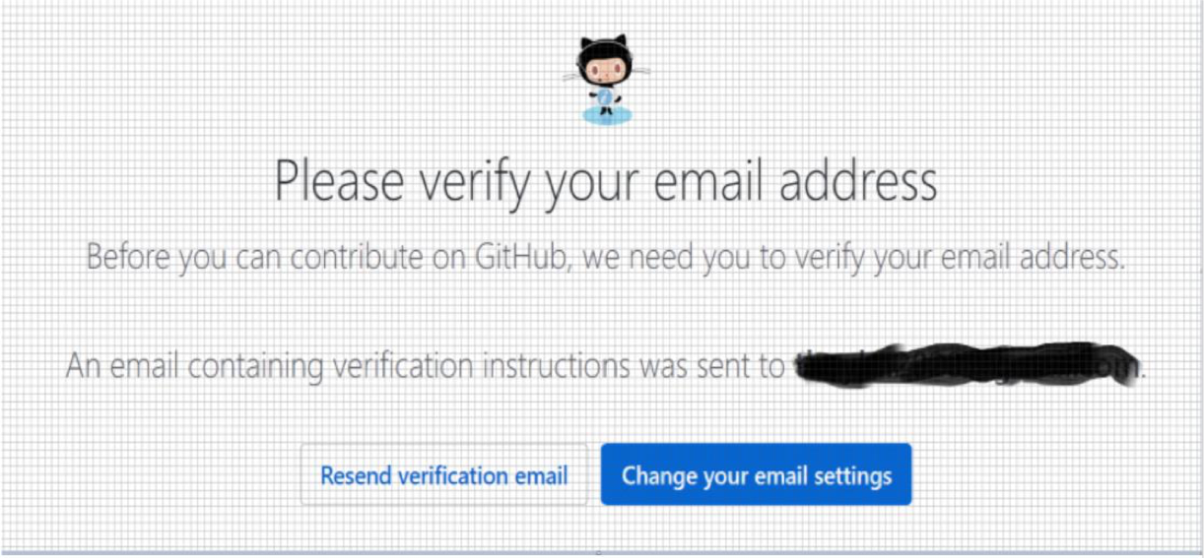

Check your email to see if GitHub has sent a verification link. If so, click on [Verify email address] to proceed with verification. If you haven’t received it, go back to the GitHub homepage and click [Resend verification email].

**1.2 SIGN IN**

**2. Create a New Repository.**

Click the plus sign icon in the upper-right corner of the screen and select [New Repository].

+ Name your repository, for example: **TechwizProject** + Choose between Public or Private depending on your needs.

+ Leave default for everything.

+ Click Create repository to complete the process.

**3. Deploying a React App to GitHub Pages**

Open the terminal in Visual Studio Code:

**3.1. Install GitHub Pages**

npm install --save gh-pages

**3.2. Add to package.json File**

"homepage": https://tqm-six-sigma.github.io/bronxluggage/,

"predeploy": "npm run build",

"deploy": "gh-pages -d build",

**3.3. Push Code to GitHub**

o git init  
o git add .  
o git commit -m "first commit"  
o git branch -M main  
o git remote add origin https://github.com/TQM-Six-Sigma/bronxluggage.git

o git push -u origin main

**3.4. Run the deploy command**

o npm run deploy

After a successful deployment, go back to GitHub: Open your repository on GitHub, click on the "Settings" tab at the top, and scroll down to the "Pages" section. Wait for about 1-5 minutes and you should see the results as shown below.

